**Week 5 – Natural Hazards and Risk Assessment**

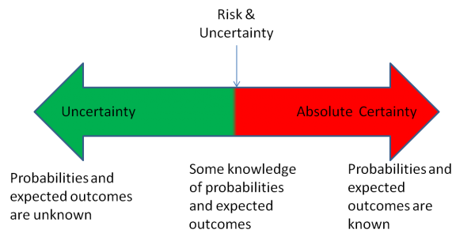

Broad Definition of Disaster – 10 or more die, 100 or more are affected, request for international assistance.

Earthquake

Landslide

Flood

Tornado

Bio – Ebola, bird flu, black plague

Volcanoes

Meteorites

**Increases in natural disasters caused by:**

* + More people
  + More people in hazardous places..Naples near Vesuvius – 3rd largest city highest 1M pop density,
  + Poverty pushes people in to hazardous places
  + Media reporting
  + Environmental damage – desertification and deforestation makes lands more likely to be affected.
  + Climate change

**Haiti EQ**

* Poor population
* Poor construction of homes and buildings (slab on grade stacked)
* Relatively small EQ – Mag 7
* According to official estimates, 316,000 people killed, 300,000 injured, 1.3 million displaced, 97,294 houses destroyed and 188,383 damaged in the Port-au-Prince area and in much of southern **Haiti**.
* Poverty played a big role
* Ebola outbreak can’t be managed by Liberia – could cause economic breakdown –
* Financial disasters hit poor people hardest – Detroit and sustainability
* Landslides and earthquakes leave poor people homeless and without jobs

**Environmental Justice**

* Means empowering people who have typically been left out of decision-making about their community. Usually poorer people with lower education levels. They don’t know how to get involved.
* Giving people a place at the table - Stericyle
* Community Building + Capacity Building + Citizen Engagement in Policy-making + Government Actions = Sustainable Environmental and Social Change
* Davis County Burn Plant - Garbage is burned
* Ash goes to the nearby landfill
* Thousands of homes in the area
* Incinerator releases dioxin and metals
* These chemicals can cause health problems
* Davis County identified a “cancer cluster” in area
* Residents file court action – burn plant installs $5 M in new equipment

**Hazards Communication**

* Uneducated people – Ebola (either Gods wrath or a plot to harm Africans)
* Nevado del Ruiz – predicted with certainty, but not accepted, 21K people dead – Pinatubo example
* Science role is to communicate the magnitude, frequency and probability of hazards

**Magnitude-Frequency Concept**

* Lots of small events and few large, 100-year flood
* Many earth features form from moderate events that occur often.
* Recent flooding a Nevada was a moderate event that occurs relatively frequently over geologic time (a few times during a human life span).
* Kill the most people – tornados and wind, lightning, floods, hurricanes, earthquakes, landslides, fires
* Huge damages – earthquakes, floods, volcanoes
* Less damage – lightning, expansive soil
* Some affected by people (landslides) other not (lightning)

**Fundamental Principles about Natural Hazards**

* Science Process – monitoring (map)
* Risk assessment and management
* Hazards are linked – earthquakes and landslide or EQ and volcanoes
* Hazardous events that previously caused a disaster are causing catastrophe as population grows
* Can minimize consequences
* **Utah Geo Survey hazards maps**
* [**http://geology.utah.gov/maps/geohazmap/**](http://geology.utah.gov/maps/geohazmap/)

**Geologic (science studies) and Human History of Hazards**

* Hazards are repetitive and their history can be understood. We can determine the recurrence intervals and magnitude.
* Uniformitarianism
* South Weber is made of flood and landslide deposits – google – **see geologic map**
* Abundant evidence of earthquakes along Wasatch front - google

**Disaster Forecasts and Prediction**

* Some hazards (floods, hurricanes, tsunamis) be predicted with short warning times
* Some hazards (earthquakes, landslides, volcanic eruptions) can’t be predicted and are FORECAST
* Probability of occurrence
* Another word for probability is uncertainty. How certain you are an event will occur

[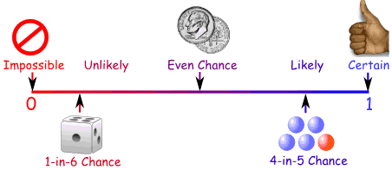](http://www.mathsisfun.com/data/probability.html)

**We Live With Risk**

* Soil and groundwater in many areas of Utah and other western states contains arsenic at concentrations of 5-25 mg/kg.
* Arsenic is a known carcinogen and poison. The EPA “risk based value” for arsenic is about 0.4 mg/kg for soil. In Utah, arsenic is usually present in soil at concentrations above the EPA “risk” value.
* Is natural arsenic in soil a problem we can do anything about? Can we do anything about lightning?
* Is there anything we can do about Radon, landslides, earthquakes, ebola – YES – Prepare and Plan to Prevent or Manage Risks

**What is a Forecast?**

Like the weather, many natural events and are forecast rather than predicted.

Example: Fault and EQ forecasts are based on evaluation of EQ recurrence and size data.

Forecasting allows you to state your uncertainties. Also, parameters factored into forecast.

Weather forecasts are based on both long term averages/statistics and recent data (doppler radar, satellites etc). Example: for the last 100 years (365 days/year x 100 years = 36,500 daily data points) in Hawaii it rains every other day and the average high is 72 degrees. If you forecast a 50% chance of rain and a temp of 72 degrees, you will be right all the time.

* + **The same basic process is applied in forecasting EQ events, landslide events and volcanic eruptions, except we have much less data.**

**Geologically “recent” is within the last 12,000 years! This leads to major uncertainties in EQ forecasting.**

**Social Consequences of Prediction**

What would happen if a large earthquake was **predicted** in Layton area within a Yr?

* + Availability of EQ insurance
  + Rescheduling of school, major events etc..
  + Business and travel decline
  + People would move
  + Public Services may be reduced
  + Property Values Drop

**Recurrence Interval** – time between large events or disasters (not the same in all cases depends on location)

**4 Elements of ALL Forecasts**

1. When/Time period of interest for your forecast. Based on when EQs happened in the past. *Can plug any time period into the model. (NOT THE SAME AS RECURRANCE)*
2. Where/Location of faults, landslide etc – if there is no fault in your area, an EQ may not affect you, … Northridge CA.
3. How Big/Magnitude (EQ Size, Landslide, Volcano, a small T-shower or 7-day downpour!)
4. Use this information to make a random statement of odds when the event will occur.

**Geological Hazards (EQ, Volcanoes and landslides) are evaluated in terms of hazard, risk and vulnerability. Climate change can also be addressed, but is global not local.**

* **Hazard** **is the event** (earthquake, landslide, car wreck etc.). The bigger the event (earthquake, landslide, car wreck etc.). the greater the hazard. Falling objects and fires hazards -
* **Risk is the loss expected from a certain event and is expressed as a probability.**
* Think like an Insurance Agent
* Replacement Values
* Auto Insurance etc.,
* **Vulnerability** **gives an idea of how you may be affected locally**.
* For example, if your house is located on soft lake bed soils that will shake a lot, you are more vulnerable to the risks of an earthquake.
* If you live on the base or top of an unstable hill you are more vulnerable to a landslide hazard than someone who lives in the center of the valley.

* Earthquake and other building codes are meant to address hazards and vulnerability to reduce risks. State and county maps show vulnerability of various hazards in certain areas.
* Old and very young more vulnerable
* People in the hospital
* Certain types of structures etc…
* **Wood-frame houses with weak connections between the walls and foundation:**  
  Wood-framed buildings are inherently flexible). However, shaking may send some of these houses sliding to one side. Frequently, the shear walls were strong enough, **but the connection to the foundation was a weak point that gave way.**
* Masonry or concrete walls not reinforced with steel bars were not flexible. If there is no steel connecting them to their foundation, the joint between walls and foundation can be a weak point.

**Risk Assessment**

* A process used to identify hazards and determine risks. Can be applied to many activities from banking to geology.
* Purpose is to reduce impact of an accident or natural disaster (or poor investment) by understanding the risks and hazards.
* Process includes several steps that help identify who is most vulnerable.

Step 1 – Define the problem or ask questions. What is the hazard? Who may be at risk? People, economy, utilities, buildings, transportation, cultural assets

Step 2 – Data collection needed to define the hazards and complete a risk assessment.

Step 3 – Assess the Risks and Vulnerabilities – Old and very young, hospital, freeway etc.

Step 4 – Propose a Solution or Risk Management Strategy